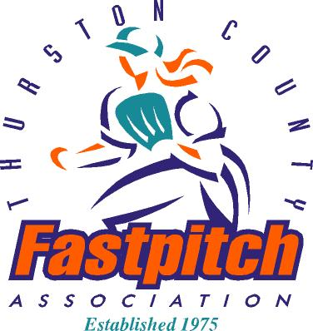
THURSTON COUNTY FASTPITCH ASSOCIATION
Recreational Softball for Girls
Thurston, Mason and surrounding Counties
PO Box 5721 Lacey WA 98509
www.thurstoncountyfastpitch.com
Message Phone: 360-350-3611

The mission statement of Thurston County Fastpitch Association is:
To operate a quality non-profit fastpitch association, to promote fastpitch softball in the community by developing skills; promote fun and team spirit; and promote and teach good sportsmanship to all players, coaches, parents and fans.

TCFA Information
Thurston County Fastpitch Association (TCFA) is a non-profit volunteer organization that has promoted girls’ recreational fastpitch softball in Thurston County since 1975. Our teams are registered and insured with the United States Specialty Sports (USSSA) which sets our rules and offers tournament play opportunities.
The division of play, established by USSSA, ensures that girls play only with others within their age group. Age is determined by the age of the girl on January 1 of the current year. 8U format is a choice of coach pitch or tee-ball.

TCFA is a non-profit organization. Each team participates in a league fund raiser. League fund raisers are an essential part of our ability to offer a quality program to the girls in our community. These funds are used to cover expenses that registration fees do not cover.

Other expected expenses: TCFA currently provides a uniform shirt and socks to all players. There may be other uniform expenses. Most teams are able to raise the funds necessary through sponsorships and team fund raisers.
Games will begin on Opening Day in April each year. All teams participate in the opening ceremony, have their pictures taken and play their first game. Each team is scheduled to play 14 games during the spring season. A championship tournament is scheduled at the end of the season for the top 4 teams from each age group.

Regular game days are as follows: 8U and 12U, Monday and Wednesday; 10U and 14U, Tuesday and Thursday. Games may be played at alternate times depending on scheduling needs. Games will be played at area fields with local teams playing home games in their local area.

Practices Teams will practice at a field near their home area.

Summer League is offered in June with registration beginning in May. More information will be posted on our website, twitter and Facebook.

TCFA on Twitter

TCFA on Facebook

